**Book Store Website Report**

**Introduction**

**Project Title:** Development of a Book Store Website **Team Members**

* S.Vignesh[aut2241270001]
* S.Surya [aut2241270012]
* S.Ragava Harish [au412721205034]
* J.Kishore [au412721205024]
* S.Shyam [au412721205044]

**Project Overview**

The online book store is a web-based application designed to make book purchasing accessible, convenient, and efficient. The website allows users to explore various books, read reviews, and purchase their favorite titles from the comfort of their homes.

**Objectives**

- To develop a user-friendly and responsive platform for book sales.

- To offer seamless navigation and purchasing features for an enhanced user experience.

- To streamline the management of inventory, orders, and customer data for store administrators.

**Scope**

The project targets book enthusiasts and aims to bridge the gap between physical stores and digital shopping. Features like advanced search, secure payment integration, and a responsive design ensure the website caters to a broad audience.

**Design and Features**

**Website Design**

The bookstore website features a clean, modern design with the following key sections:

- Home Page: Highlights popular books and current promotions.

- Catalogue: A dynamic list of books organized by genres, authors, or user preferences.

- Book Details: A dedicated page for each book featuring detailed information and purchase options.

- Shopping Cart: Displays selected items, allowing users to modify their cart before checkout.

- Authentication Pages: Login and signup forms for user accounts.

**Key Features**

- Search Functionality: Users can search books by title, author, or genre. Autocomplete suggestions improve search accuracy.

- Filters and Sorting: Filters for price, genre, and ratings help users refine their selections.

- Responsive Design: The layout adapts seamlessly to different screen sizes.

- Secure Checkout: Integration with trusted payment gateways ensures a safe transaction process.

**Technologies and Tools**

**Frontend Development**

- React.js: Used for creating interactive user interfaces. React's component-based architecture ensures reusable and scalable code.

- React Router: Enables smooth navigation between pages without full-page reloads.

- CSS Frameworks: Tailwind CSS or Material-UI were used to maintain a consistent and visually appealing design.

**Backend (Optional for Integration)**

- Node.js and Express: Handles server-side operations and API routing.

- Database: MongoDB or Firebase stores book and user data securely.

- API Integration: Google Books API or a custom backend fetches book details dynamically.

**Deployment Tools**

- Platforms like Netlify or Vercel were used to host and deploy the website.

- GitHub was employed for version control and team collaboration.

**Development Process**

**Planning and Analysis**

The project began with requirements analysis and wireframing to define the application’s structure. Key features were prioritized for an iterative development approach.

**Implementation**

- Homepage Design: Dynamic content sections were created to display promotions and trending books.

- Catalogue Development: API integration was used to fetch book data dynamically, and filters were implemented to organize the data.

- Authentication System: User accounts were built using Firebase Authentication for secure login and signup.

- Shopping Cart: A persistent cart system using local storage or global state management with Redux or Context API.

**Testing and Debugging**

- Unit Testing: Tools like Jest were used to test individual components.

- End-to-End Testing: Cypress was utilized to simulate user interactions and ensure seamless navigation.

**Challenges and Future Enhancements**

**Challenges**

- API Limitations: Adjusting to API rate limits while ensuring smooth user experience.

- Performance Optimization: Ensuring the website performs well with large datasets, especially on slower networks.

- Secure Payments: Integration with payment gateways required extra care to prevent security vulnerabilities.

**User interface**

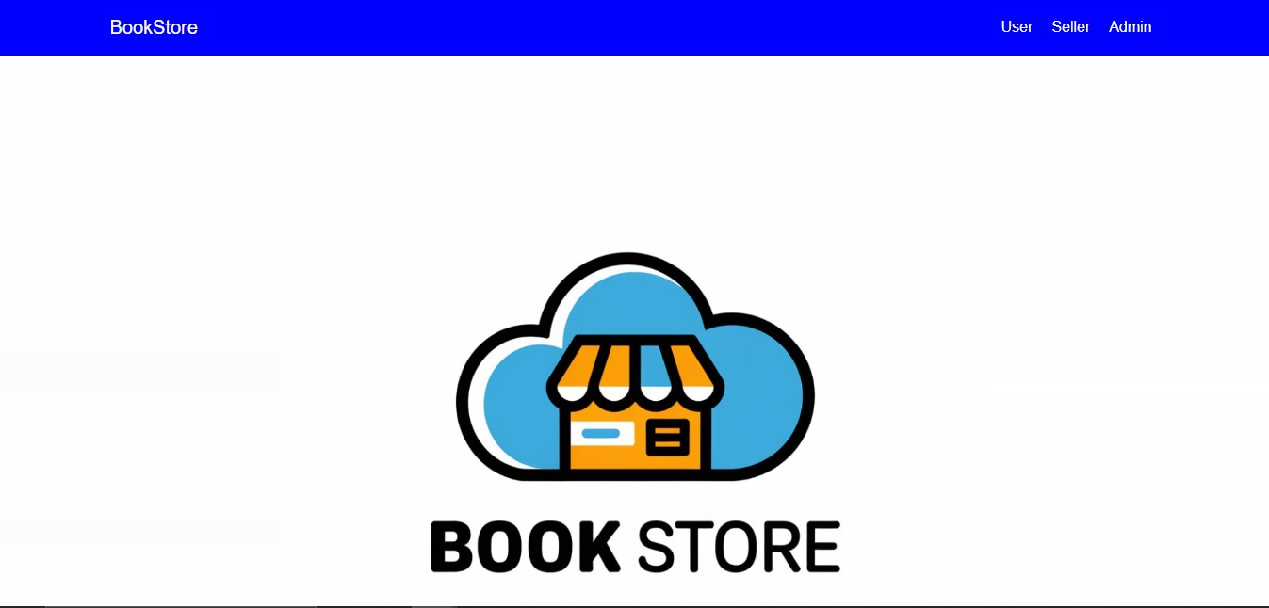

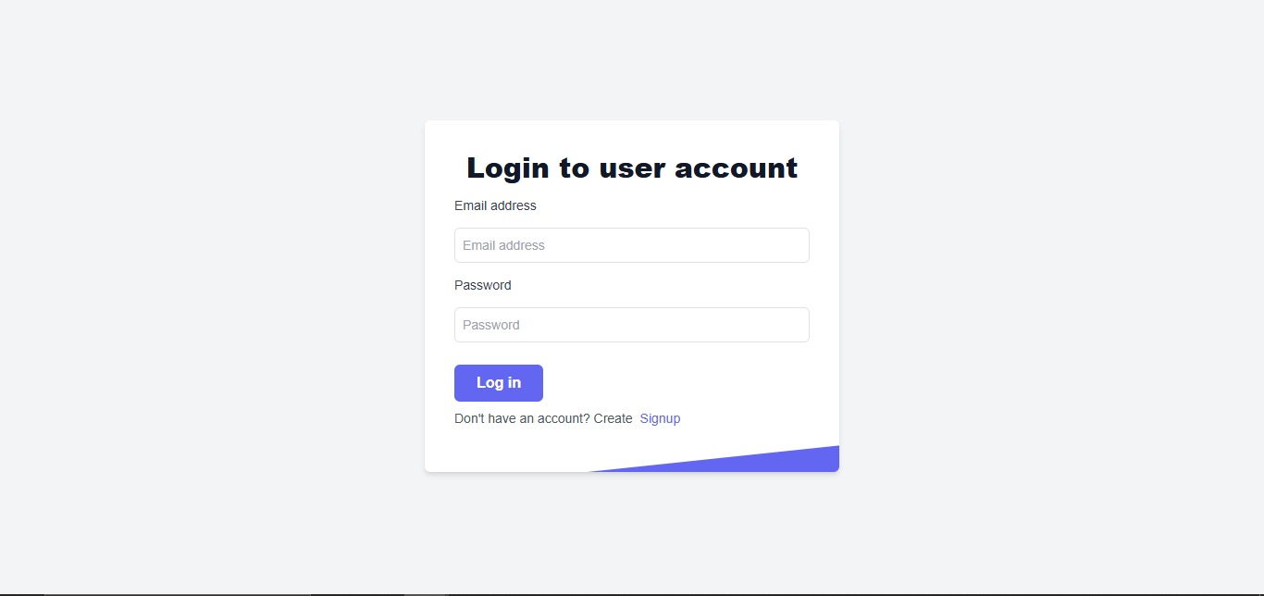

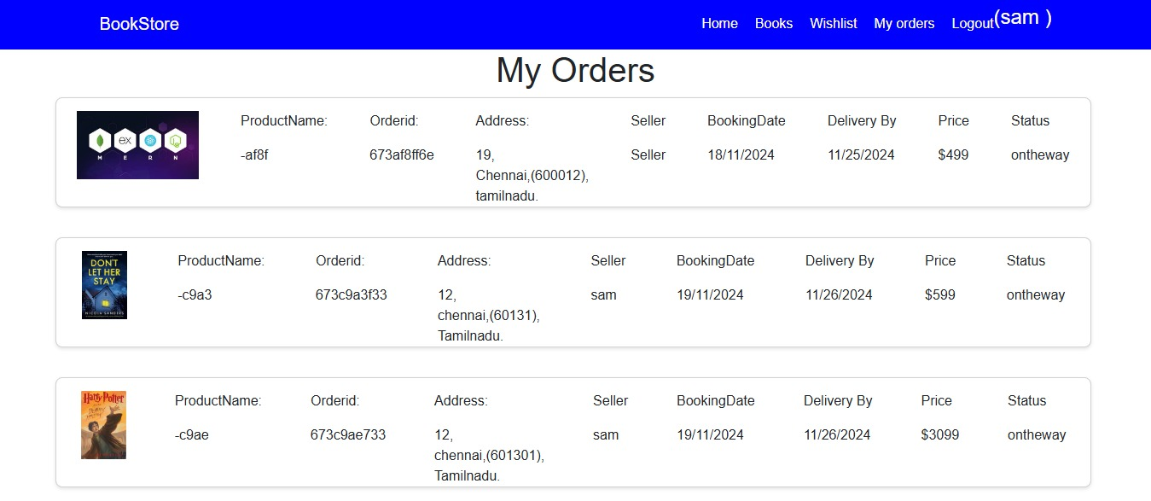

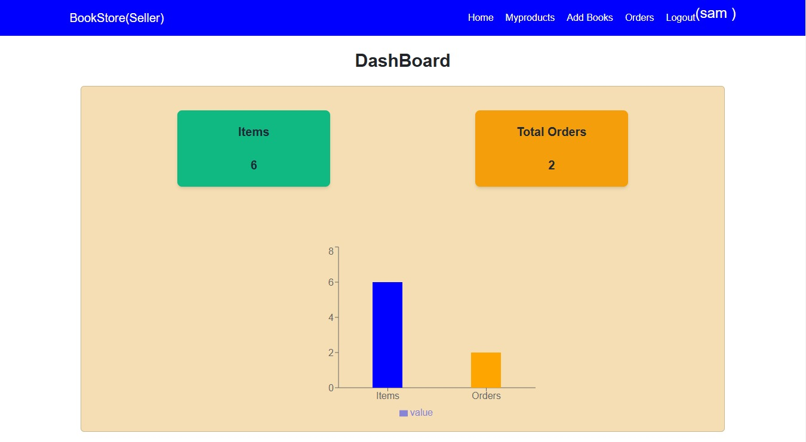



**Future Enhancements**

- AI-Based Recommendations: Suggest books based on user preferences and browsing history.

- Enhanced Review System: Enable users to leave detailed reviews and star ratings for books.

- Admin Panel: Build a dedicated dashboard for store administrators to track sales and inventory.

- Mobile Application: Expand the website into a cross-platform mobile app for better reach.

**Conclusion**

The online book store project showcases the potential of React.js in creating scalable and user-centric e-commerce solutions. This project not only improves customer convenience but also demonstrates the capability to adapt to evolving user needs in the digital age.This five-page report highlights the comprehensive development of a book store website using React.js, detailing its features, technologies, challenges, and future prospects.